Finite Element Simulation of Processes Involving Moving Heat Sources. Application to Welding and Surface Treatment
J.M. Bergheau¹, V. Robin², F. Boitout²
- LTDS, UMR5513 CNRS/ECL/ENISE, 58, rue J. Parot, 42023 Saint Etienne Cedex 2, France
- SYSTUS International, 84 Bvd Vivier Merle, 69485, Lyon Cedex 03, France
Abstract: A wide range of welding and surface treatment processes involve the use of a heat source which is moving at a constant speed over the component. The numerical simulation of such processes implies a transient analysis using a very refined mesh in order to follow properly the path of the heat source. The 3D-mesh size can be very large if one consider the welds length or the heat-treated surface size in industrial components. To reduce the computational time to acceptable values, several techniques have been investigated.
The first type is to use analytical methods such as Rosenthal equations. The second type of solutions consists in performing a transient analysis using adaptive meshing. But, for a large proportion of the involved processes, practical experience demonstrates the existence of quasi steady state conditions over the major part of the heat source path. Numerical algorithms have therefore been developed to directly compute the steady temperature, metallurgical phase proportion and stress distributions.
This paper gives a general overview of the different numerical methods used to simulate welding and surface treatment processes with a special emphasis on the steady state calculation. The benefits and limitations of each of them are discussed and applications are presented.
Key Words: Welding, Surface Treatment, Moving Heat Source, Finite Element Simulation, Analytical Solutions, Adaptive Meshing, Steady-State Calculation.

Introduction
A wide range of welding or surface treatment processes involve the use of a heat source moving at a constant speed over the surface of the component. Three dimensional computation of residual stresses and distortions induced by this kind of processes, using the usual finite element method, needs very refined meshes in order to correctly describe the properties and stress gradients in the heat affected zone along the path of the heat source. In this paper, we discuss the different numerical approaches, implemented in SYSWELD® software, which can be used to do realistic simulations of these processes. We will not present the approach used for the modelling of interactions between heat transfer, metallurgy and mechanics which is described in details in [1].
In a first part we discuss the use of analytical methods based on Rosenthal solution to the thermal problem involving a moving point source through an infinite medium. In a second part, we present an adaptive meshing technique, which enables transient simulations. But, practical experience shows the existence of a quasi-steady state over a large part of the source path. A numerical procedure for the direct computation of steady temperature, phase proportion and stress distributions is therefore presented in section 3. Such a procedure reduces the number of steps to obtain the steady state to only one and thus greatly decreases the computation time and the cost of the analysis.
We finally discuss the benefits and drawbacks of each method and propose a methodology for the 3D numerical simulation of welding and surface treatment of complex industrial components.

1. Analytical solutions for the steady temperature distribution
We consider a welding or surface treatment process involving a moving heat source. The heat equation, under steady-state conditions, in a moving frame associated with the source, takes the following form:
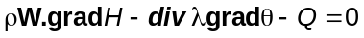 (1)
In the above equation, ρ is the density, H, the enthalpy of the material, Q represents the heat source distribution and W is the speed of any point of the structure. For a movement of translation, W simply equals -V, V being the velocity of the heat source. In equation (1), thermal properties can be temperature dependent in the general case. Of course, classical boundary conditions such as prescribed temperature or heat flux must be associated with the equation above.
If the thermal properties (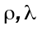 and 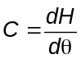) are supposed to be temperature independent, and in the case of a point heat source (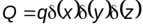) moving at a constant speed V (for example along the x direction) through an infinite 3D-medium, then equation (1) can be written (in cartesian coordinates):
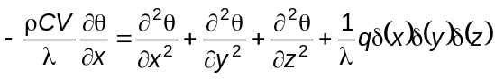 (2)
Therefore, 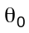 being the initial temperature of the medium, a solution of equation (2) can be found (see for example [2][3][4]):
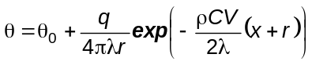
with 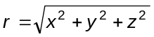.
If one considers a moving point source (q) on a 3D semi-infinite medium (Fig.1), then for symmetry reasons, the solution becomes:
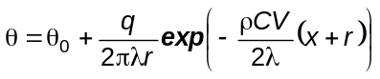 (3)
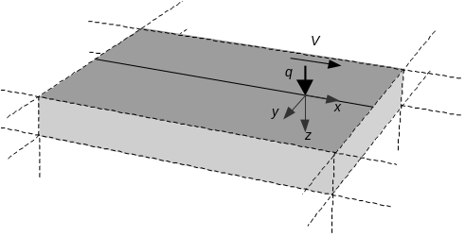
Fig. 1 Point source moving on a 3D semi-infinite medium
The solution (3) can be extended to 3D finite media using the conventional method of images [4]. Let’s consider now an infinitely long heated plate (Fig.2), width a, thickness b. This finite medium is equivalent to a semi-infinite medium with special conditions such that the heat flux vanishes on planes located at 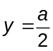, 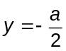, 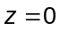 and 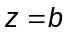.
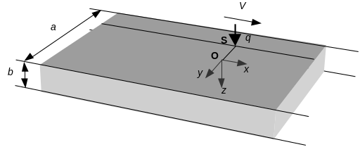
Fig. 2 Point source moving on a 3D finite medium
To account for the conditions on the plane for example, one simply has to consider a second heat source located symmetrically to the first one with respect to the plane and to superpose the solutions corresponding to both point sources:
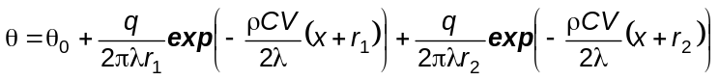
with 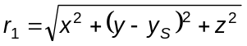 and 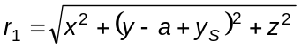, 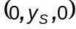 being the coordinates of the heat source. Then to account of the conditions on the plane , one has to consider symmetry conditions on all the planes 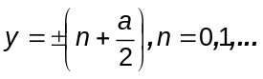. This leads to consider an infinite number of heat sources located at 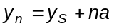 if n is even and 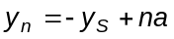 if n is odd.
By applying the same approach for the z direction, one finally finds:
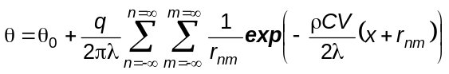 (4)
with 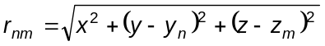, if n is even, if n is odd and 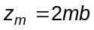.
Of course, at each point considered, the temperature calculation is stopped when the sources located far from the point considered do not induce significant changes of the temperature.
The generalisation of equation (4) to any source shape can be simply obtained by integrating the solution on the heat source surface S:
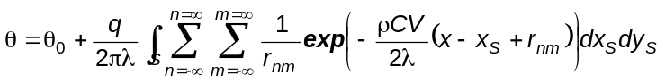
with 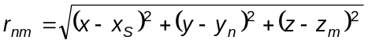.
The advantage of such a method is that temperature calculation is quasi-instantaneous. But the method presents two main drawbacks. The first one concerns the thermal properties that must be temperature independent and this is not realistic for the processes involved here. The second one comes from boundary conditions that are limited to zero heat flux conditions. Moreover, as far as residual stresses and strains calculation is concerned, a finite element mechanical analysis will be necessary. Therefore, it will be probably better to use the finite element method also to perform the thermal analysis which is not time consuming as compared to the mechanical analysis.

2. Transient analysis using adaptive meshing
But within the frame of welding or surface treatment process simulation with the finite element method, the user is led to produce very voluminous three-dimensional models to take precisely into account considerable thermal gradients generated by a moving heat source. Therefore special numerical techniques have to be involved.
The adaptive remeshing technique consists in cutting a mesh locally according to the position and nature of the source (form, intensity…). This application allows the user to reduce the size of meshes. Since the thermal loads move on the structure, it is necessary to refine an initial coarse mesh at several step corresponding to various positions of the source. For this reason, the use of a principle such as “moving refinement” needs to be associated with a physical quantities transfer from a refined mesh toward another one to carry out a full simulation of the process as illustrated below (see Fig. 3).
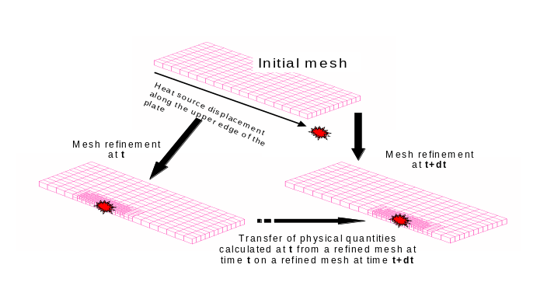
Fig. 3 Procedure description

2.1 Remeshing principle compared with graded elements technique
The remeshing technique consists in a dichotomous cut of any classical type of elements, from first order elements like 8 node hexahedrons, 6 node prisms or 4 node tetrahedrons to second order elements of the same shape. Unlike graded element methods [5][6], all kinds of isoparametric elements can be used with this technique. Indeed, this technique creates a discontinuous mesh between refined and coarse areas because of nodes located at the middle of edges or faces. In order to preserve inter-element continuity, constraint elements have to be employed. These elements are connected to the mid-edge or mid-face nodes (“dummy nodes”) and to the nodes describing the entity on which they lay (edge or face). The stiffness matrix of these elements has to impose some relation between the displacements of all these nodes as shown in Fig. 4. This is achieved using either a penalty method or a Lagrange multiplier method.
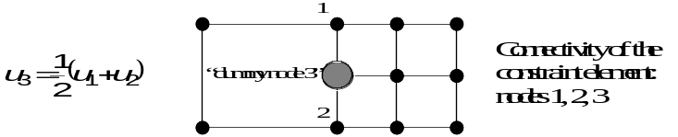
Fig. 4 Discontinuous square mesh
In Fig. 4, the constraint element is composed of nodes number 1, 2 and 3.
Let us call X_{i}, the coordinates of node i belonging to the edge or face considered and X₀ the mid-edge or mid-face node coordinates. 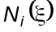 is the shape function associated with the i^{th} node of the element corresponding to the edge or the face. Then we get:
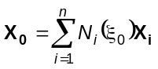
where n is the number of nodes describing the edge or the face on which the “dummy node” lies and 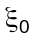, the reduced coordinate corresponding to the point X₀ inside this element.
With the same convention, the displacement relation can be written:
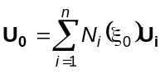
The nodal unknown vector and the stiffness matrix associated with the constraint element and corresponding to the penalty method therefore is:
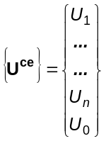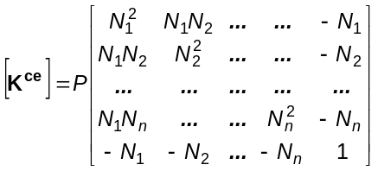
where P represents the penalty coefficient.
Using the Lagrange multiplier method, an additional unknown has to be considered: the Lagrange multiplier λ associated with the relation on the displacements. Therefore, the nodal unknown vector and the matrix of the constraint element are the following:
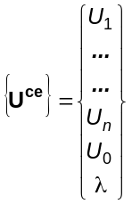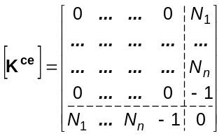
Beside these numerical considerations, the criteria used to refine or not a mesh area has to be established. For simulation of welding, an obvious way consists in adapting the element size to the heat source applied to a structure. Indeed thermal and mechanical fields from the welding processes have large gradients close to the bead. Then, the required element size may be given by a space-time function describing a space distribution of the element size directly related to the shape of the heat source and it’s trajectory on the structure. Another simple solution that has been experimented with SYSWELD® should consist in making first a full transient computation on a coarse mesh. Then, according to a prescribed maximal value of any data variation (temperature, stresses or other) inside each element of the mesh, it is possible to evaluate the number of times that an element has to be cut in order to get an acceptable data variation.

2.2 Data transfer techniques
Transient analyses dealing with “moving refinement” have to be associated with data transfer from one mesh refined at time t to an other one refined later at time t+Δt (Fig. 3). Indeed, refinements at several steps modify the mesh topology, changing node and Gauss point locations. Some areas become coarser whereas some others tend to be more refined. Transfer of quantities known at the nodes doesn’t raise any particular problem. Each node of the new mesh is projected onto the initial mesh. The element of the initial mesh with its reduced coordinates is then known and the quantities assigned to the “new” node can be calculated using the shape functions of the element.
Transfer of known quantities at integration points of the elements is more delicate. Different kinds of data transfer for 3D models from and to coarsening and refined meshes are discussed in [7]. The two kinds of techniques that have been implemented in SYSWELD® are described now.
The first one, simple and rapid gives rough results. The quantities at the nodes of the initial mesh are averaged. The integration points of the new mesh are then projected onto the initial mesh, and finally the new values are computed, using the shape functions of the initial mesh. In no case does this method provide for compliance with behaviour law of the material.
The second method is more accurate because it consists in only transferring nodal values (temperature or displacement). No extrapolation has to be done. Indeed, SYSWELD® offers the possibility to store the displacement history of a whole transient process. This displacement history can be used to rebuild any physical data at a specified time step by reintegrating the behaviour law of the material involved. This method is then more advisable because of the perfect compatibility between the nodal displacements and the results at integration points, although it requires more computation time for the rebuilding process.

2.3 Example
The studied structure is a solid plate (length=350mm, width=70mm, height=15mm) with a plane of symmetry in relation to its length. Thus, only half of the plate is modelled. The upper part of the plate is subjected to a laser heat source, comparable to a gaussian source (mean radius=6mm, heat flux=456W), moving at 5mm/s. The centre of this source is moving along the upper edge of the plane of symmetry. The temperature of the plate is initially homogeneous and equal to 20°C. The results of the full transient computation are presented in Fig. 5.
Fig. 5 Full transient thermal computation
All the refined meshes are obtained from a 700 elements coarse mesh. In this case, the space-time function giving the map of the required element size depends on the heat source radius. For example, if the centre of an element is further than 4 times the source radius, it is not cut. The biggest meshes obtained, at time t=25s and t=30s, contain about 4000 elements. The space-time function keeps an acceptable refinement behind the heat source in order to take account of the temperature gradients produced at the rear of the source. Several steps of calculation are computed on each mesh. This kind of procedure requires much less computation time than a simulation made on a mesh refined along the whole bead.

3. Steady state computation
For the mechanical aspects, the origin of this idea goes back to Nguyen and Rahimian for the analysis of the motion of a crack in an elastic-plastic medium [8]. The technique has been later applied to the calculation of residual stresses in a rail through the action of train wheels [9][10].
For the simulation of welding and surface treatments, we need the computation of temperature, phase proportions and stresses. This is achieved by solving the problem in a moving frame associated with the heat source. The approach implemented in SYSWELD® can deal with a uniform translatory, circular or helical motion. The later option is especially interesting to simulate coating processes in cylindrical parts. Of course, rigorously speaking, for a translatory or helical motion, steady-state conditions only exist for components presenting an “infinite” length in the direction of motion and for a circular motion, for a continuous motion of the heat source and after a large number of turns. But in practice, experience shows that quasi-steady state conditions are fulfilled for a large part of the heat source path even for a circular motion in only one turn.
The calculation of the residual stresses and deformations is then performed in two steps. First a steady-state computation in the heat source co-moving frame gives the temperature, phase proportion, stress and strain distributions corresponding to the end of the quasi-steady state conditions. Then, starting from the results of the previous simulation, a transient calculation is performed for the end of the source path and the final cooling.
Of course the direct computation of the steady state only needs one step. But, one very interesting feature is that such computation needs a mesh refined only near the source position.

3.1 Thermal and metallurgical analysis
Here, we have to deal with a diffusion-convection problem represented by equation (1) with appropriate boundary conditions. It is well known that applying the Galerkin method to such problems in order to formulate finite elements leads to spurious spatial oscillations of the solution for high Peclet numbers 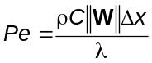, denoting the mesh size, typically 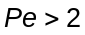 with first order elements. To avoid such oscillations, Hughes and Brooks [11] have proposed to use a Petrov-Galerkine variational formulation with special discontinuous test functions. This is the method used in the software.
The integration of the metallurgical transformation kinetics rests upon a quite different approach. The mesh must now be such that nodes and Gauss points form streamlines. These streamlines are parallel to the heat source trajectory. Therefore, the 3D mesh of the component must be generated by propagation of the 2D mesh of a cross section.
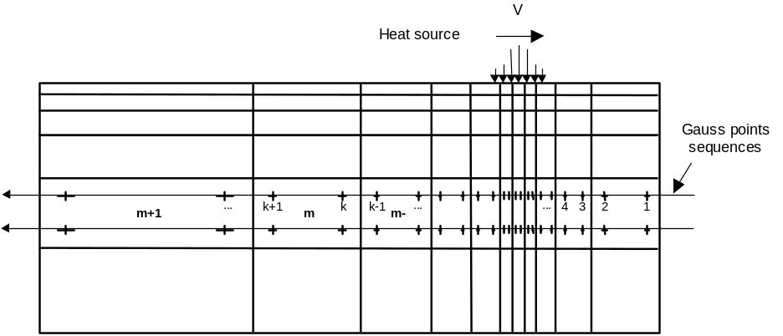
Fig.6 Gauss points sequences
A pre-processor then determines the elements and Gauss points sequences corresponding to path lines as it can be shown in Fig.6. For each Gauss point, the pre-processor determines the number of the preceding Gauss point on the streamline as well as the number of the element to which it belongs, and the pseudo time step 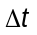 corresponding to the time needed for the heat source to go from the previous Gauss point. Of course, this pseudo time step is calculated from the positions of the Gauss points and the speed of the heat source.
Using this information, the classical numerical procedure for the calculation of phase proportions evolution with time can be used. Let’s recall that this procedure computes phase proportions step by step. At each time step, phase proportions at time 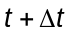 are calculated starting from phase proportions at . Here, of course, phase proportions at the beginning of each step must be replaced by the final phase proportions obtained for the previous Gauss point on the streamline.
One can note that the latent heat effects are also taken into account without any modification of the subroutines computing the finite element vectors and matrices. Indeed, in the case of a mixture of phases, the density and the enthalpy are computed according to:
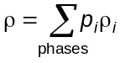
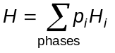
where 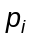, 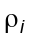 and 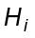 represent the proportion, the density and the enthalpy (function of temperature) respectively of phase i. The equation (1) then becomes:
(5)
with: 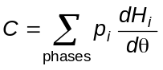
In equation (5), the last term corresponds to the latent heat effect. It is clear that with the method proposed for the determination of Gauss points sequences, 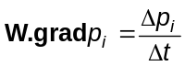, where 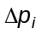 and respectively represents the increment of the proportion of phase i and the pseudo time step between two successive Gauss points on a streamline. Therefore:
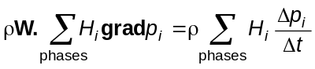
which is quite the same as the term taken into account in a transient step by step analysis.

3.2 Mechanical analysis
The mechanical analysis rests upon the classical equilibrium equations, which can be written:
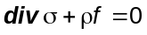
This approach significantly differs from the one proposed by Inoue and Ju in [12] which consists in solving the equilibrium equation written in an incremental form.
The only difficulty to be solved here concerns the integration of constitutive equations of the material. We use the same approach as the one presented above for the integration of the metallurgical transformation kinetics. The subroutines dedicated to the solution of the constitutive equations at each integration point are used. These subroutines usually calculate, at each time step, the state variables (i.e. stress components, plastic strains, hardening parameters, etc.) at time from the state variables at time . Here again, the state variables at the beginning of the step must be replaced by the state variables just previously computed for the preceding Gauss point. Nevertheless, in the case of a circular or helical motion of the heat source, one must take care to do the adequate rotation operations to express the components of the vector and tensor state variables of the preceding Gauss point, in the frame associated with the actual Gauss point.
The method has been validated by comparison to transient step by step analyses. As an example, Fig.7 shows the hoop stress along the weldment obtained through steady-state and transient approaches for the simulation of laser welding of 2 aluminium cylinders (diameter 920 mm, thickness 3.8 mm, height 80 mm). For the comparison, the same mesh has been used for both analyses: 250 uniform subdivisions for the circumference, 5 for the height and 1 through the thickness. The heat source is distributed through a con shape, represents a total power of 1,257 kW and is moving at a constant speed equal to 0,1 turn/min. The steady-state simulation has been performed for a heat source located at an angle of 355° from the initial position. The transient mechanical simulation need 125 steps and a computation time about 30 times bigger than the one needed by the steady-state analysis. Moreover, the efficiency of the steady-state approach would have been improved if one had used a mesh only refined near the source position instead of choosing a regular meshing along the circumference.
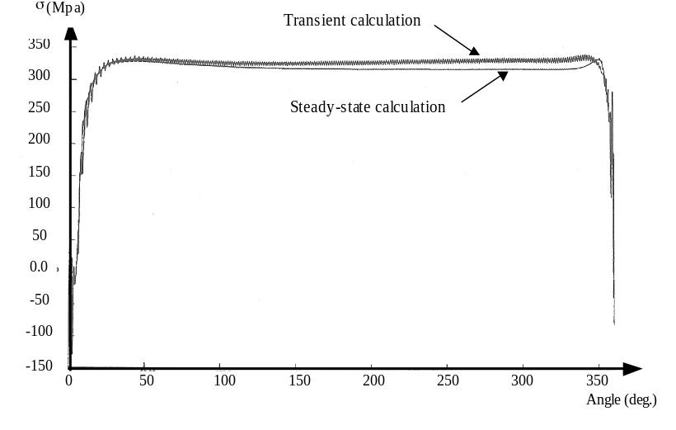
Fig.7 Hoop stress along the weldment
Comparison between transient and steady-state analyses
This procedure has been used successfully for the simulation of surface treatment or welding processes. Details can be found in [13][14]. The application presented in Fig.8-9 concerns the welding of two structures (a L structure and a plate) [15]. The material involved is a structural hardened aluminium alloy. The precipitate dissolution gives rise to a weak phase in the heat affected zone. Therefore the simulation takes account of 2 phases: a hard, initial one and a weak one.
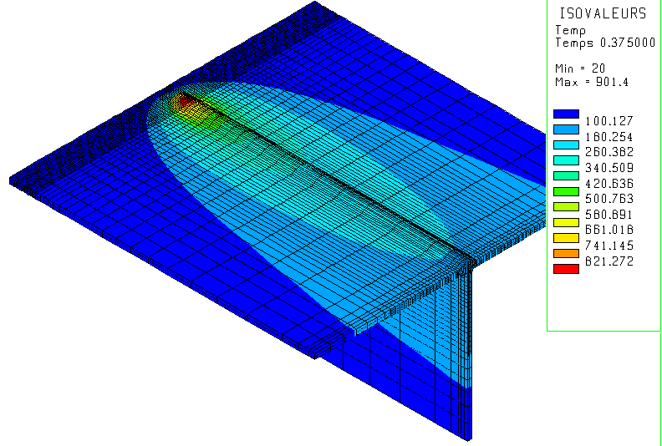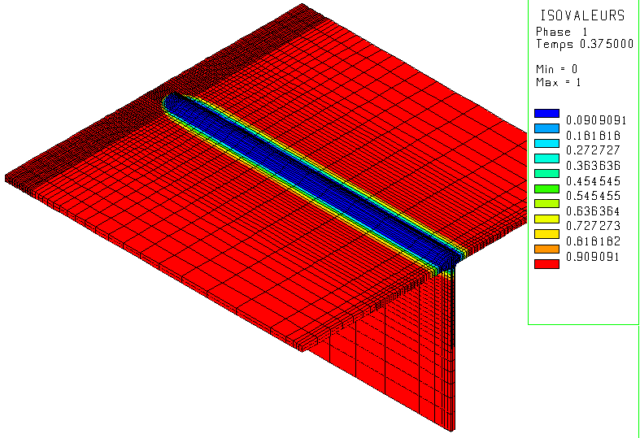
Fig.8 Welding of 2 aluminium plates Fig.9 Welding of 2 aluminium plates
Steady temperature distribution Steady hard phase distribution

4. Conclusion
We have detailed, in this paper, different simulation techniques of processes involving a moving heat source such as surface treatments or welding.
Analytical methods, based on the Rosenthal solution to a thermal problem involving a moving point source in an infinite medium and then generalised to finite media and volumetric heat sources, give fast results. But these methods are limited to thermal problems. Moreover, they do not integrate different non-linearities such as the temperature dependency of the thermal properties and the boundary conditions. Therefore, finite element simulations involving the modelling of complete non-linear interactions between heat transfer, metallurgy and mechanics will be necessary in most cases. Nevertheless, analytical solutions will be useful to calibrate data input concerning the heat source, using an inverse approach.
The transient analysis using adaptive meshing enables to take account of all the physical phenomena involved accurately. Nevertheless, one has to perform a complete transient analysis that needs both lots of CPU time and disk space.
The steady state calculation procedure enables to compute steady temperature, metallurgical phase proportions, stresses and strains directly. But to use such a procedure, steady-state conditions must be fulfilled that is generally the case for a translation, circular or helical motion of the heat source on a quasi-infinite medium. Moreover, the end of the process (exit of the torch and final cooling) has to be computed using a transient analysis procedure.
Therefore, the method we suggest for the 3D simulation of industrial thermal processes involving a moving heat source, associates direct steady-state computation, if steady-state conditions are fulfilled, and the adaptive remeshing technique. First a steady-state calculation using the numerical procedure presented in section 3 is performed. Then a transient step by step simulation using adaptive remeshing can be realised to simulate the end of the source motion and the final cooling, starting from the results of the steady-state calculation.

References
- Bergheau J.M., Boitout F., “ Contribution of finite element simulation to the analysis of bulk and surface heat treatments”, Proc. 7th Int. Seminar of IFHT, Budapest, 1999, pp. 303-313.
- Rosenthal D., “Mathematical theory of heat distribution during welding and cutting”, Welding Journal, Vol. 20, 1941, pp.220-234.
- Rosenthal D., “The theory of moving sources of heat and its application to metal treatment”, Trans. ASME, Vol. 48, 1946, pp.849-866
- Carslaw H.S., Jaeger J.C., Conduction of heat in solids, Oxford University Press, New York, 1959.
- Lindgren L.-E., Häggblad H.-A., McDill J.M.J., Oddy A.S., “Automatic remeshing for three-dimensional finite element simulation of welding”, Comp. Meth. Appl. Mech. Engrg, 1997., 147, pp. 401-409.
- McDill J.M., Goldack J.A., Oddy A.S., Bibby M.J., “Isoparametric quadrilaterals and hexahedrons for mesh grading algorithms”, Comm. Appl. Numer. Methods 3 1987, pp. 155-163.
- McDill J.M., Oddy A.S., “Data transfer for 3-D h-adaptive thermal-elasto-plastic finite element analysis”, Simulations of materials processing theory, methods and applications, in: Proc. Numiform ‘95, Ithaca, New York, 1995.
- Nguyen Q.S., Rahimian M., “Mouvement permanent d’une fissure en milieu élastoplastique”, Jour. de Mec. Appl. 5, 1981.
- Dang Van K., Inglebert G., Proix J.M., “Sur un nouvel algorithme de calcul des structures élastoplastiques en régime stationnaire”, 3ème colloque sur les tendances actuelles en calcul des structures, Bastia, 1985.
- Maitournam H., “Résolution numérique des problèmes élastoplastiques stationnaires”, Thèse de Doctorat de l’ENPC, 1989.
- Hughes T.J.R. and Brooks A., “A theoretical framework for Petrov-Galerkin méthods with discontinuous weighting functions : application to the streamline upwind procedure”, Finite Element in Fluids, Wiley, New York, 1982.
- Inoue T. and Ju D.Y., “Simulation of solidification and viscoplastic stresses during vertical semicontinuous direct chill casting of aluminium alloy”, Int. Jour. of Plas., 1992, Vol. 8.
- Bergheau J.-M., Pont D. and Leblond J.B., “Three-dimensional simulation of a LASER surface treatment through steady state computation in the heat source comoving frame”, Mechanical Effects of Welding, IUTAM Symposium Lulea, edited by L. Karlsson, L.-E. Lindgren, M. Jonsson, Springer-Verlag, 1992, pp. 85-92.
- Leblond J.B., Pont D., Devaux J., Bru D. and Bergheau J.M., “Metallurgical and mechanical consequences of phase transformations in numerical simulations of welding processes”, Modeling in Welding, Hot Powder Forming and Casting, Chapter 4, pp. 61-89, edited by Pr Lennart Karlsson, 1997, ISBN 0-87170-616-4, ASM International.
- Gooroochurn Y.,”Simulation par éléments finis des distortions résiduelles dues au soudage d’une structure de carrosserie”, PFE report, ENISE, SYSTUS International, 1999.

Equilibrium equations are written 

